# INTRODUCTION

* 1. 1.1.Overview

Analyzing housing prices in metropolitan areas of India provides valuable insights into one of the country's most dynamic and complex real estate markets. These metropolitan areas, such as Mumbai, Delhi, Bangalore, and Chennai, are magnets for economic activity and urbanization, making them focal points for housing demand and price fluctuations.

* 1. 1.2.Purpose

1.Informed Decision-Making

2.Policy Formulation

3.Economic Indicator

4.Real Estate Industry Insight

5.Risk Assessment

6.Urban Planning

7.Academic Research

1. **Problem Definition & Design Thinking**
   1. 2.1.Empathy Map

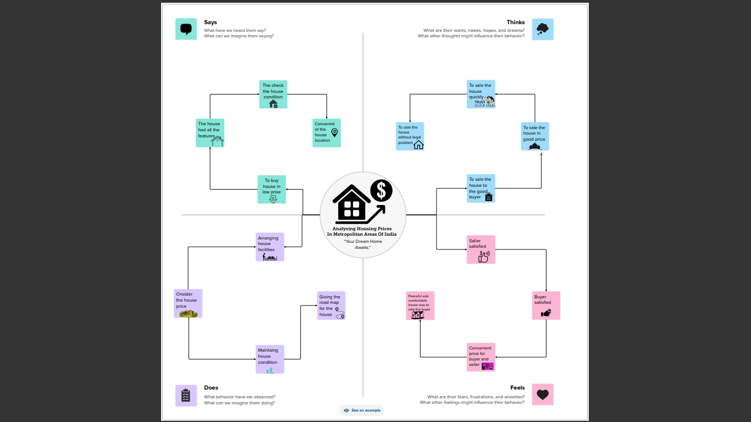

* 1. 2.2.Ideation & Brainstorming Map

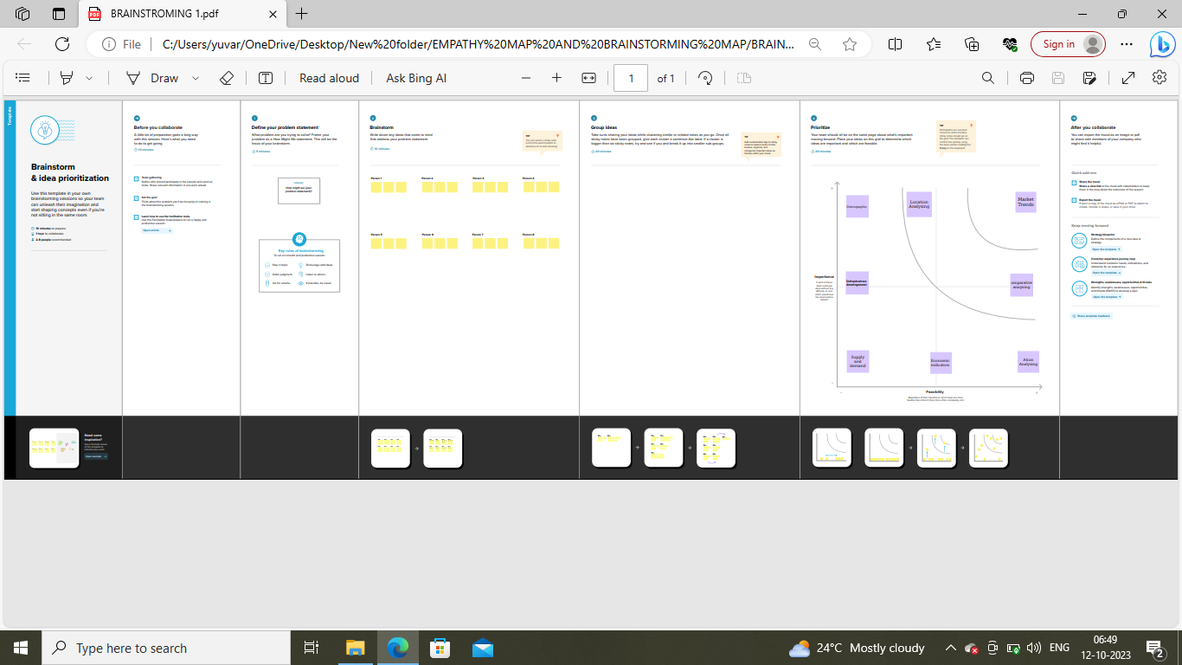

# RESULT

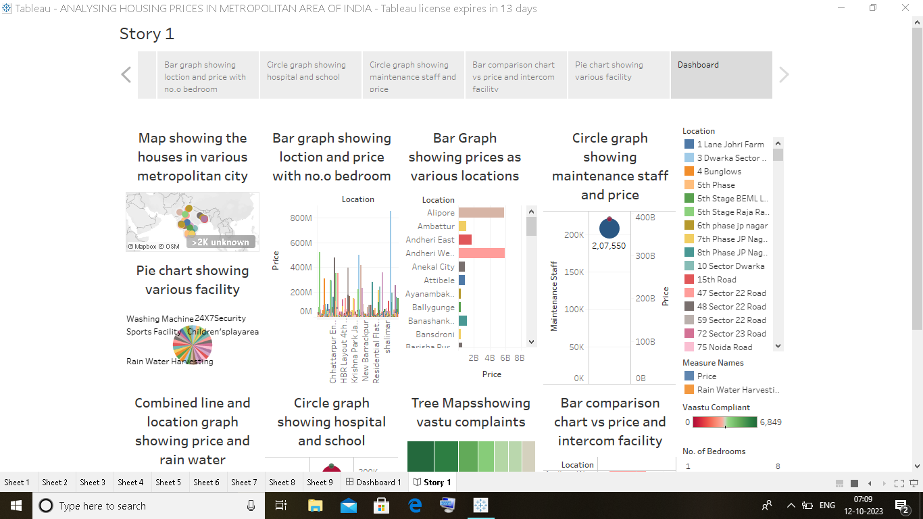

# ADVANTAGES & DISADVANTAGES

4.1.Advantages

1.Informed Investment Decisions

2.Market Transparency

3.Government Policy Impact

4.Economic Indicator

5.Wealth Building

6.Risk Mitigation

7.Urban Planning

8.Real Estate Industry Support

9.Research And Education

10.Market Competitiveness

4.2.Disadvantages

1.Data Inaccuracy

2.Rapid Market Changes

3.Overreliance on Historical Data

4.Regional Variability

5.Market Manipulation

6.Affordability Concerns

7.Policy Lag

8.Economic Externalities

9.Inequality

10.Environmental Impact

# APPLICATIONS

1.Real Estate Investment

2.Homebuying

3.Property Valuation

4.Government Policy

5.Risk Assessment

6.Urban Planning

7.Market Transparency

8.Research and Academia

9.Forecasting

10.Sustainable Developmen

# CONCLUSION

In conclusion, analyzing housing prices in metropolitan areas of India is a multifaceted endeavor with far-reaching implications. This analysis provides valuable insights into the complex dynamics of the real estate market in some of India's largest cities, including Mumbai, Delhi, Bangalore, and Chennai.

Through detailed examination, stakeholders, including investors, policymakers, homebuyers, and real estate professionals, gain a comprehensive understanding of the factors influencing housing prices. This knowledge empowers them to make informed decisions, whether it's for investment, home purchase, policy formulation, or urban planning.

# FUTURE SCOPE

1.Data Analytics

2.Sustainability

3.Smart Cities

4.Affordable Housing Initiatives

5.Demographic Shifts

6.Real Estate Technology

7.Policy Impact

8.Economic Factors

9.Global Trends

10.Social and Cultural Factors